

Finance Administrator/ Personal Assistant to CFO
- South African Heritage Resources Agency
- Zonnebloem
- Permanent
- Full Time
- Published:
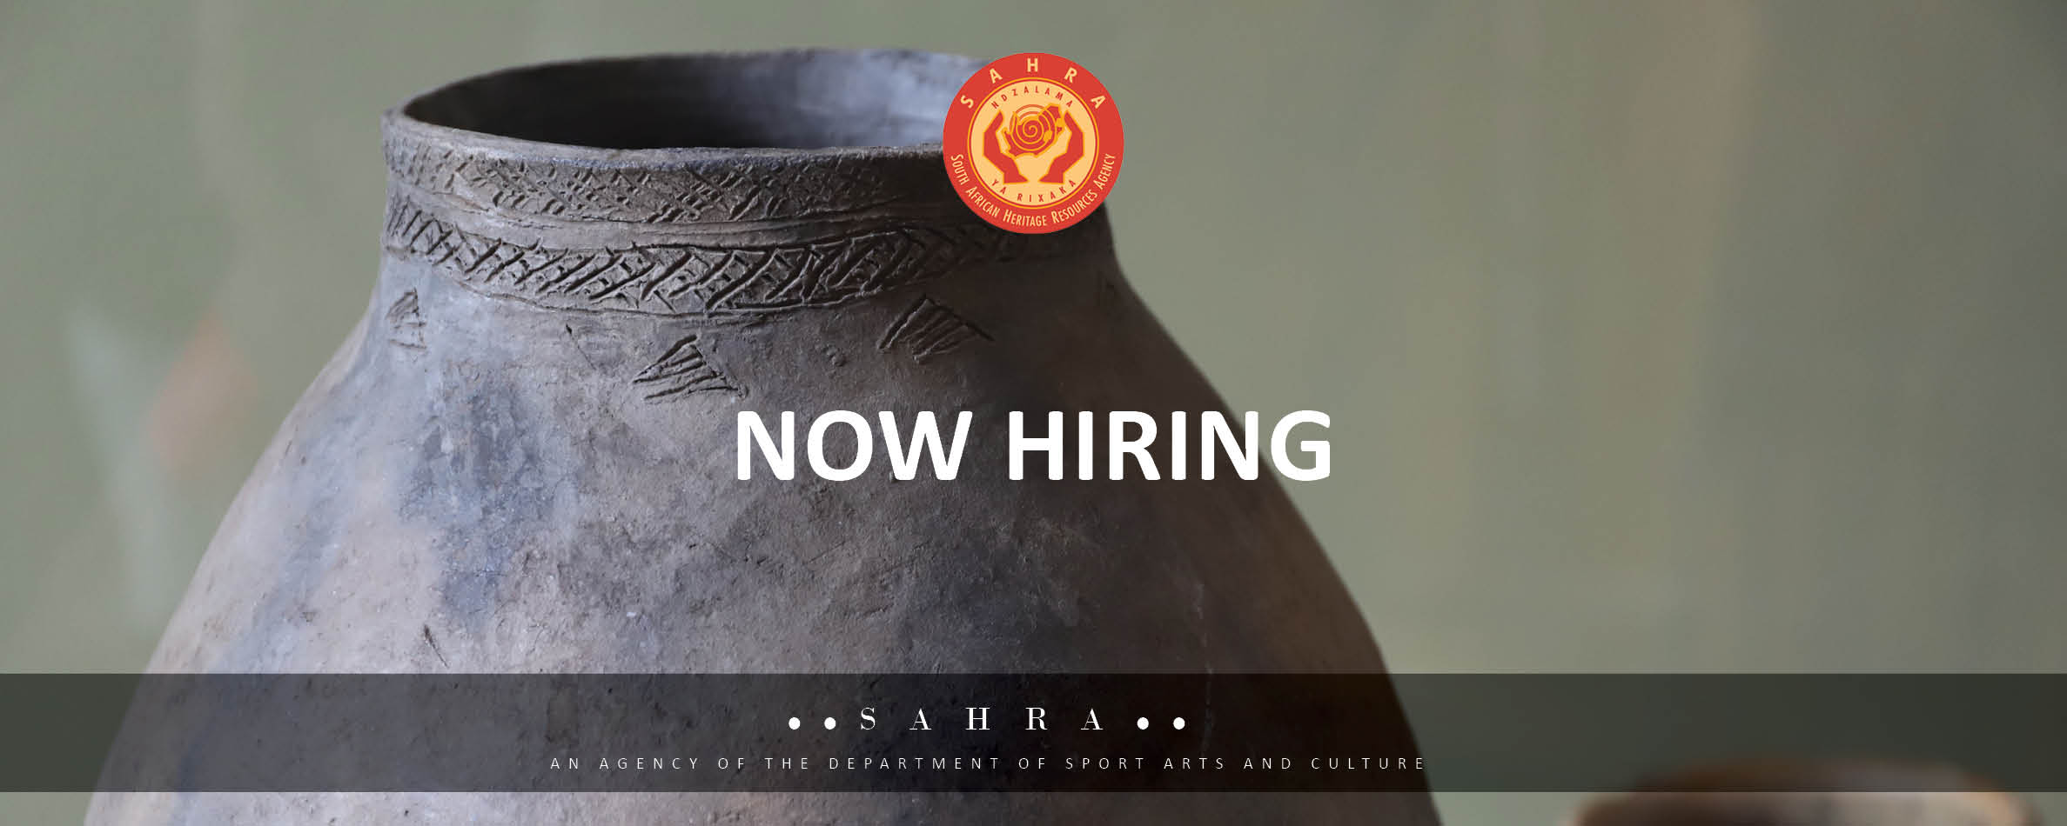
Introduction
JOB TITLE: Finance Administrator/ Personal Assistant to Chief Financial Officer (CFO)
DEPARTMENT: Finance Management
LOCATION: Head Office CT
APPROVED GRADE: C1
Basic salary: R200 634.00 per annum
Closing date: Tuesday, 17 March 2026

Primary Purpose of the Job:
To provide personal assistance and administrative services to the incumbent of the Executive Officer- Finance position and office.

Duties & Responsibilities
Administrative Support:
- Efficient arrangements of meetings/functions [internal and external]
- Ensure appointments are scheduled timeously with relevant information.
- Provide personal assistant services support to the Chief Executive Officer.
- Acknowledge in writing receipt of letters or documents.
- Proactively plan and managing CFO's office and arrangements for the Financial Management Unit
- Maintain an up-to-date register of all deadlines for all tasks and meeting resolutions required from the units

Internal and External Communication:
- Enhance communication and liaison within the unit and with other units as well with external stakeholders.
- Attending queries to and from the office of the CFO including some queries related to the units.
- Maintain professional organisational image in respect to dealings with internal and external parties.
- Facilitating submission for signing and dissemination.

Document Management:
- Implementing and maintaining the record filling in line with the registry file plan and maintaining the unit shared drive folder content.
- Confidential documents are properly maintained and located with ease.
- Effective filing is maintained for easy retrieval of documents.
- Producing quality minutes for all meetings within 10 working days after the meeting.

Logistical support:
- Communicate diary commitments in advance to the CFO.
- Order and manage the stationery of the organisation.
- Manage the movable assets of the CFO’s office.
- Proactively align manual and online calendar meetings with the real time requests to the Office of the CFO.
Travel Management
- Communicate effectively with Administrators or Team members.
- Provide travel expertise to all travellers.
- Research and handle travel complaints
- Administration of Process-maker for bookings
- Process travel transaction and Invoices on the ACCPAC Accounting System
- Ensuring that all travel Purchase Orders are issued for all travel requests in line with travel policy and cost containment

Desired Experience & Qualification
EDUCATION and/or EXPERIENCE:
- Advanced Diploma in Office Administration or any relevant qualification.
- Minimum of 5 years' work experience in an Executive support environment.

Other skills required:

- Proficiency in Microsoft Office Suite Records Management.
- Managing Work Processes
- Knowledge of applicable legislation

Soft Skills:
- Strong communication and interpersonal skills,
- Ability to work under pressure,
- Attention to detail,
- Documentation and organizational skills.

LANGUAGE SKILLS:
Ability to read and interpret documents such as safety rules, operating and maintenance instructions, and procedure manuals. Ability to write routine reports and correspondence. Ability to speak effectively before groups of customers or employees of organisation.

NUMERICAL SKILLS:
Ability to calculate figures and amounts such as discounts, interest, commissions, proportions, percentages, area, circumference, and volume.

REASONING ABILITY:
Ability to solve practical problems and deal with a variety of concrete variables in situations where only limited standardization exists. Ability to interpret a variety of instructions furnished in written, oral, diagram, or schedule form.

LICENSES:
A valid Code B (08) driver’s licence.

COMPUTER SKILL:
Computer literacy with regard to the use of Excel, Word and Power Point, Windows Server, Windows 10/11.

PHYSICAL DEMANDS:
The physical demands described here are representative of those that must be met by an employee to successfully perform the essential functions of this job. Reasonable accommodations may be made to enable individuals with disabilities to perform the essential functions.

While performing the duties of this Job, the employee is:
- Occasionally required to stand.
- Regularly required to sit.
- Often to talk and hear.
Specific vision abilities required by this job include close vision.

WORK ENVIRONMENT:
The work environment characteristics described here are representative of those an employee encounters while performing the essential functions of this job. Reasonable accommodations may be made to enable individuals with disabilities to perform the essential functions.
The noise level in the work environment is usually moderate.

